Twitter Text Analysis Explanation:

1. I have done the assignment using my own scraper to scrape Twitter and store data in CSV file. My results are on screenshots, and also in the python notebooks. My csv file (used for this exercise and analysis also attached), all codes, assignment, analysis and scraping, is also attached.
2. My twitter key details:

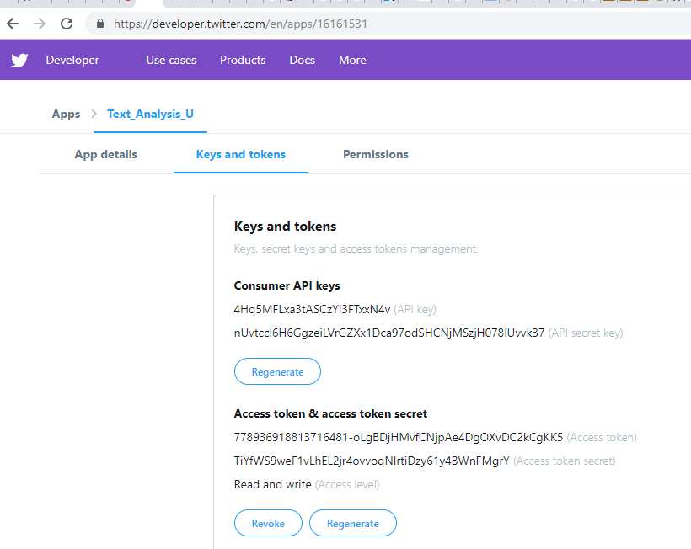

1. twitter_csv.ipynb file has the code to scrape twitter data into csv file. (Just sample code, all columns might run longer). Code looks like:

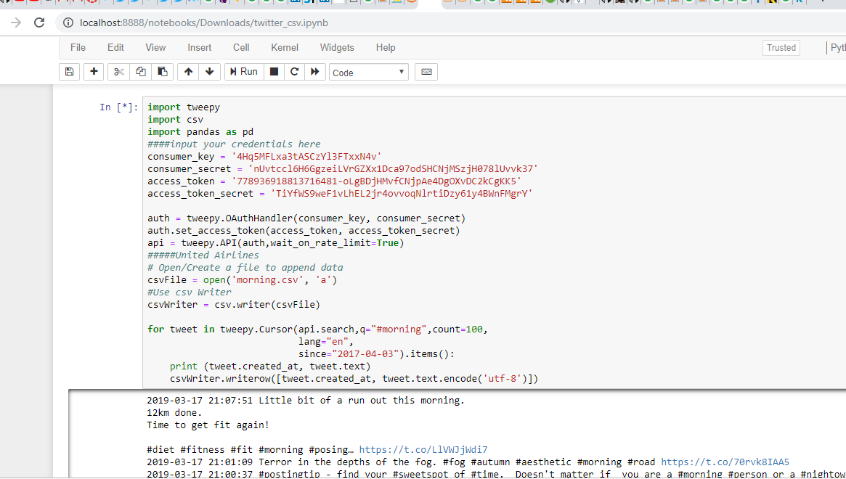

1. Twitter_Assignment.ipynb file has the assignment code.
2. The solutions to the questions are as follows:

With the help of the retweet count, I have found top retweets and the users from the document. Just sorting the count and retrieving the values.

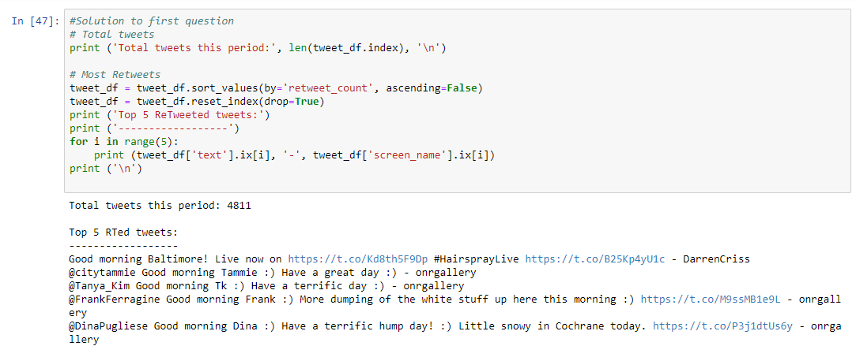

With the help of the followers_count, we can predict users with most followers, by sorting them:

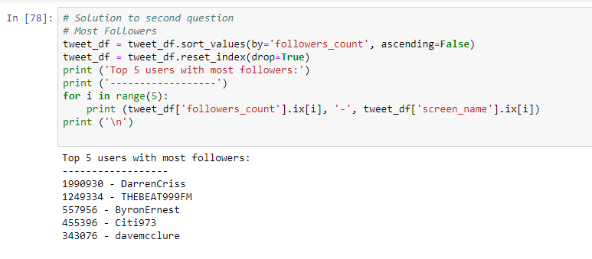

By grouping the names, we can check who tweeted the max number of times:

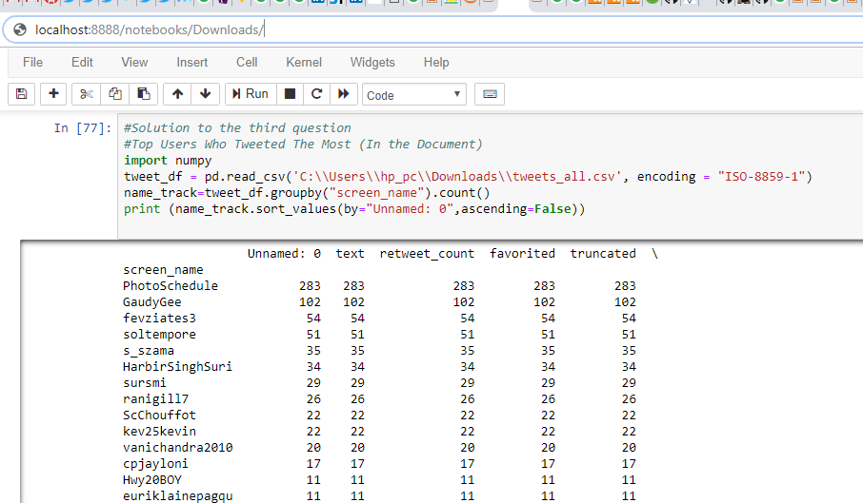

By dividing the time section, we can see top tweeters of the hour. We use head(), to get top 5:

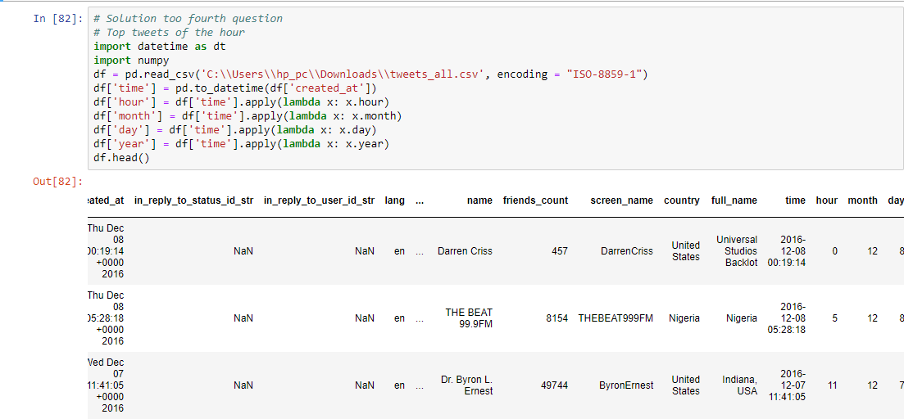

1. For further analysis:

Have used word cloud to understand pattern, sentiment analysis to look into positive and negatives. Preprocessed the data before, removed stopwords, punctuations etc.

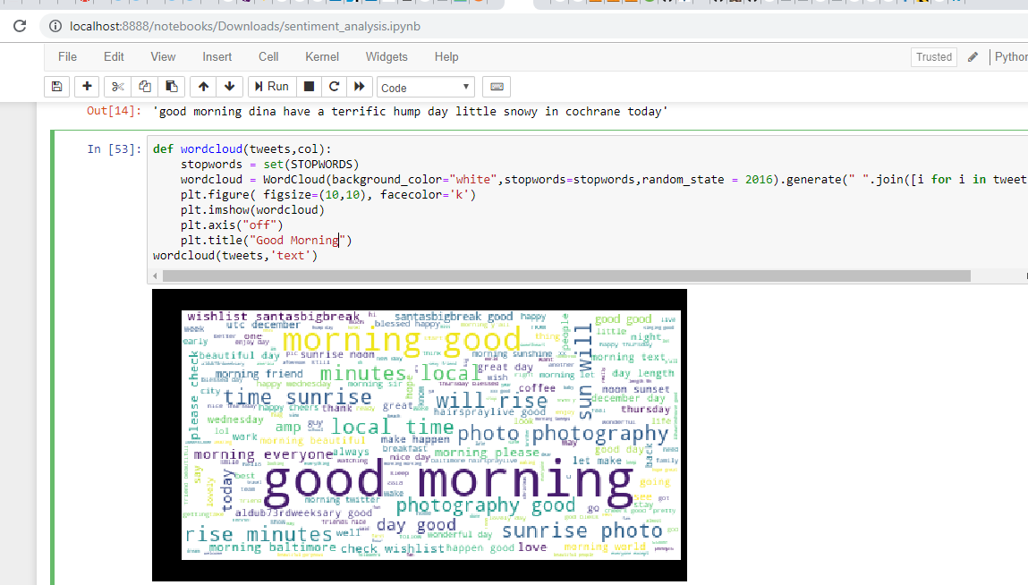

We also looked into location wise tweets:

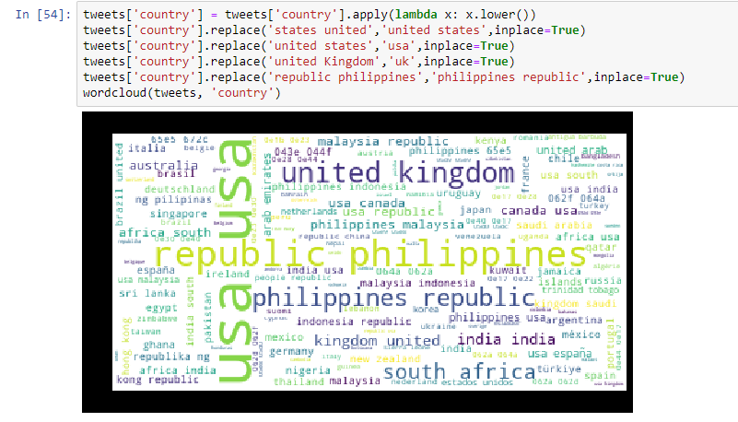

Various comparisons:

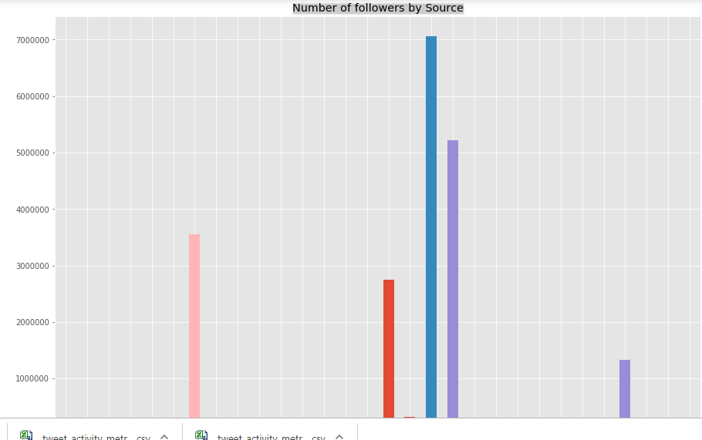

Calculating sentiment analysis:

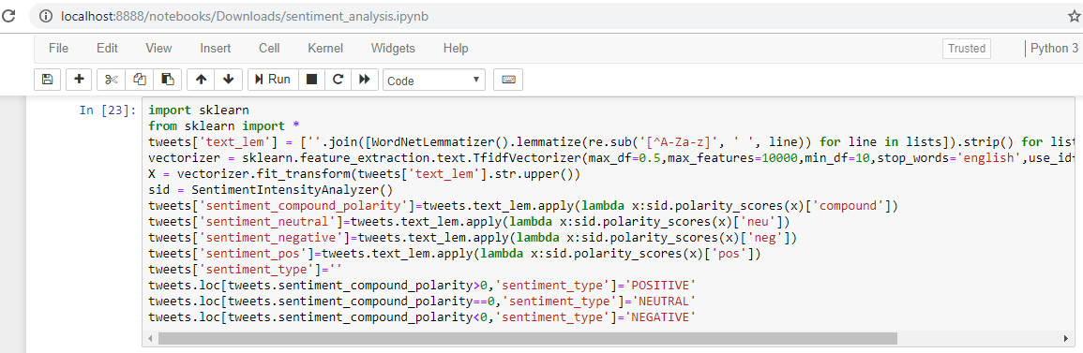

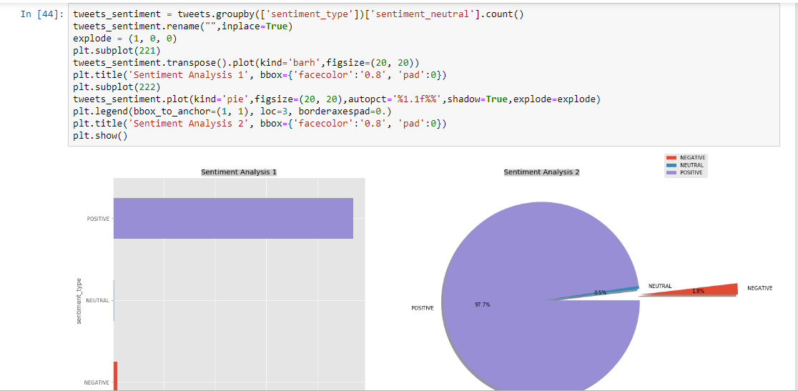

Having a quick look at positive and negative tweets:

